Indian Institute of Technology, Kanpur
Students’ Gymkhana

End Term Report - Chairman, Students’ Senate (2012-13)

March 20, 2013

It is just over 1 year ago that I took charge at this place only. While preparing the report, I reflected over the past 12 months and what my term saw. I had taken the post with the vision of improving the image of the Students’ Senate among the student body of IIT Kanpur and the image of Student Gymkhana among the faculty and institute administration. My basic aim was to take the Students’ Senate closer to the general body because I believe this is the only way the Students’ Senate and Students’ Gymkhana, in general, can attain its former glory, what it had 10-15 years back and realize its true purpose. Looking at the present situation, I believe that though we have taken some important steps in the right direction, but still it is a long way to go before we can say that the Students’ Senate is truly serving the purpose with which it was started.

Major highlights of the tenure

Trouble in the beginning:

The term started with just a few weeks left and many important tasks to be completed before the end-semester exams:

- Hall Allocation Policy (HAP): Last year saw major troubles with the HAP, because of the IAC recommendation to have no 1st year students in a single room and infrastructure crunch for accommodation. There were major protests in as well outside the Senate by hall 10 residents. Also, an emergency Senate meeting had to be called just before the end-semester exams. However, I would like to appreciate the efforts by President, Students’ Gymkhana and Mr. Karthik Balasundaram who made sure there was minimal trouble in implementation in July. I hope HAP this year is not as much a source of trouble given the infrastructure crunch is less severe this year with some new residence space becoming available. 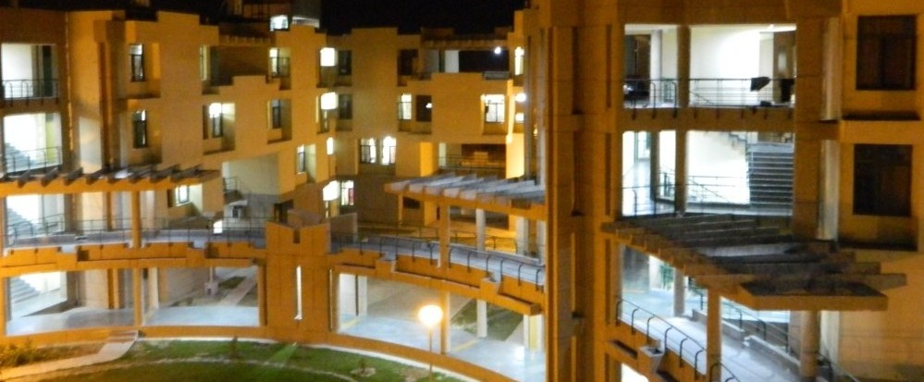
- Annual Budget – This also saw a lot of issues that were brought directly to the floor of the Senate. It was not a pleasant scene to see a few club coordinators showing displeasure over the decisions of Executives and Finance Committee.

Summers and JEE – A Success

Proposed changes in UG admission to IITs was a big issue during the summers while I was not on campus. Though operating from Singapore on my intern made it difficult to put up an effective protest, however, the Senate put up a really brave front which was appreciated not only by the students and faculty at IIT Kanpur but also by outsiders. It also caught the attention of media as the letter from the Students’ Senate to the Chairman, Academic Senate (Director) was published by NDTV and reported by a few other media channels as well. Finally, a compromise could be reached in the matter.
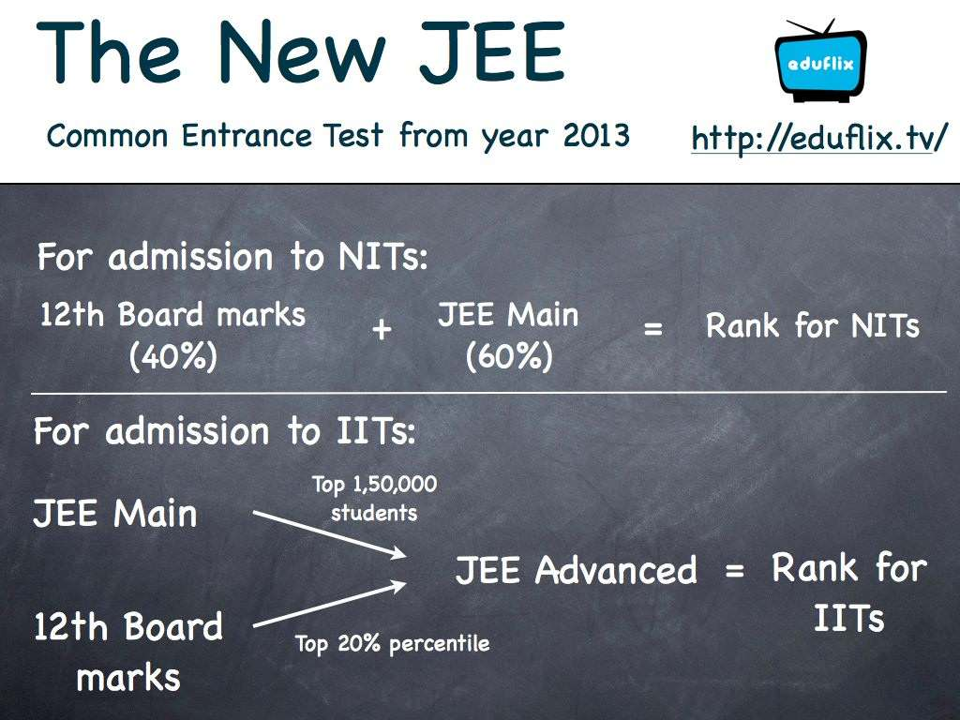

Golden Jubilee Issue

There were many concerns related to the financial allocation and other proceedings for Gymkhana Golden Jubilee. I believe the root cause of the problems was bypassing of extremely important procedures. The lesson I learnt from the whole fiasco and something that I believe everyone in Students’ Gymkhana should keep in mind in the future is that all the important policy decisions, very importantly financial allocations, must be made only by the Senate on the recommendation of the concerned standing Committee, if any, as enshrined in the Gymkhana Constitution. I agree that moving according to the given procedures is sometimes difficult, but whenever a decision regarding finances is to be made, we need to be extremely careful, transparent and methodical in our proceedings.

Action taken Reports and Website

I believe that we have had some success in streamlining the working of the Students’ Senate by the introduction of Action Taken Reports. Also, by the introduction of an easy to update-website for the Students’ Senate, we have made reasonable progress in taking the Students’ Senate one step closer to the student body. The site can be viewed at the following link:
http://students.iitk.ac.in/ss/home/

Suggestions for the incoming Senate:

- Before bringing any issues to the Senate, an attempt should be made that a consensus is reached in the corresponding standing committee. For example – it should be attempted that Hall Allocation Policy is brought to the Senate only after a consensus is reached in COSHA on the policy.
- Unlike many other IITs, we do not have an Academic Affairs Council and at present the same work is carried out by President and Chairman. I feel that as a consequence of this, many things related to academics that need to be carried out are not actually done or are neglected amongst the load of other important activities. Though, I see merits in continuing with the present system, however, I believe we need the following changes in order to make the handling of academic affairs better:
  - An academic affairs cell needs to be created under the Presidential Council to organize sessions for academic awareness. An example of a session that should be conducted is for 1st and 2nd year UG students is to educate them about the course work involved and option available through a particular branch. This way, the student can make a much more informed decision while applying for branch change.
  - Elections should be conducted for DUGC and DPGC in August beginning. This can be taken up by Chief Election Officer, Students’ Gymkhana with the help of departmental societies and academic affairs cell as proposed above. As elaborate elections for 12 UG depts., 12 PG depts. and 6 IDPs may not be feasible; elections can be carried out through a process similar to that of Chairperson, Students’ Senate.
  - UGSAAC and PGSAAC should be revived as standing committees of the Students’ Senate and any agenda before discussion in Senate should first be discussed in these committees. With the PGRC Reports coming this year, I believe we shall require an active PGSAAC
- Chief Election Officer must be selected in the month of April, i.e. before the summers. Further, By-elections should be conducted as early as possible and with a period of 6 days instead of 4. General Elections should be conducted as soon as possible in January.
- Committee of Festival Affairs should be constituted and the experience gained from its working for a year can be used to bring suitable constitutional amendments.
- The section on festivals in the constitution should be amended to make the procedures clear, concise and in line with the present requirements.
- Action Taken Report must be included as a fixed agenda in the order of business.
- Mid-Term reports should be taken up in September end or October beginning instead of November beginning.
- Presentation of Preliminary Reports for inter-collegiate festivals should be carried out on the weekend before the festival. The deadline for submission of MOUs (Friday before the Festival) must be followed strictly.
- Presentation of Preliminary Reports for inter-hostel competitions (Takneek, Galaxy etc.) must be carried out at least a week before its starting and not just 1 or 2 days before the start of the festival.
- I have often felt that individual members of the committees do not contribute as much as they should and most of the work is carried out by the Conveners of the corresponding committees. I believe that the scenario needs to be changed in this respect.
- The Students’ Senate website must be updated regularly for the meetings and reports of the sub-committees also besides the meetings of the Students’ Senate. It should also be used to bring transparency in finances of Gymkhana. Further, important information from standing committees of the Academic Senate should also be put up regularly on the website.

Suggested Schedule for next term:

- March-April:
  - Formation of standing committees of Students’ Senate
  - Hall Allocation Policy
  - Annual Budget
  - Selection of Chief Election Officer
  - Getting suitable replacements for student members in academic Senate standing committees who are graduating as well for those who are not in campus for summers
  - Formation of Techkriti Core Team and COFA for Udghosh and Antaragni
- May – July:
  - Getting the Budget passed from the administration
  - Elections for student members in DPGCs for the departments/IDPs in which all students stay back in summers
- August:
  - Election of DUGC and remaining DPGC student members – This needs to be given priority as new DUGCs/DPGCs become operational from 1st September. Hence the results must be conveyed to administration by the middle of August
  - By-elections for Senators
  - Selection of students’ senate nominees for standing committees of Academic Senate – SUGC, SPGC, SSAC etc. – must be ratified by the Students’ Senate by the end of August as elections for Chairpersons of these committees happen in September and functioning starts from 1st October.
- September:
  - Mid-Term Reports from Executives and standing committees of Students’ Senate and finance reallocation, if necessary
- October-November:
  - Core Team Formation for next year’s Udghosh
  - Approval of schedule for general elections
- January:
  - General Elections
  - Core Team Formation for next year’s Antaragni
- February
  - Elections of Chairperson, Parliamentarian and Conveners of standing committees of Students’ Senate – This should be done as early as possible in order to give enough incubation time to these students
- March
  - Charge Handover should be done as soon as possible in the month of March, as recommended by the Constitution

I would like to thank the steering committee members and the Webmasters for their invaluable assistance throughout my term. Also, I would like to thank Mr. Karthik Balasundaram and Ms. Jyoti Gupta for their help in procedural and other matters related to the functioning of Senate; Mr. Ankur Pandey, students’ senate nominee to SUGC for his help in handling the academic affairs and Mr. Anurag Sahay for his help in making the minutes, many reports and without whose help, it might never have been possible for me to introduce the concept of Action Taken Reports.

For the love of poetry that I possess, I would like to quote a Hindi translation of a few lines from a famous Punjabi poem as it is extremely similar to what I wish to say at the end of this tenure to Senators as well as students in general:

Jinka geet bana nahi paya, unse maafi chahta hun;
Jinka dard ghata nahi paya, unse maafi chahta hun;
Main kaam jink aa nahi paya, unse maafi chahta hun;
Jinka geet bana nahi paya, unse maafi chahta hun;

