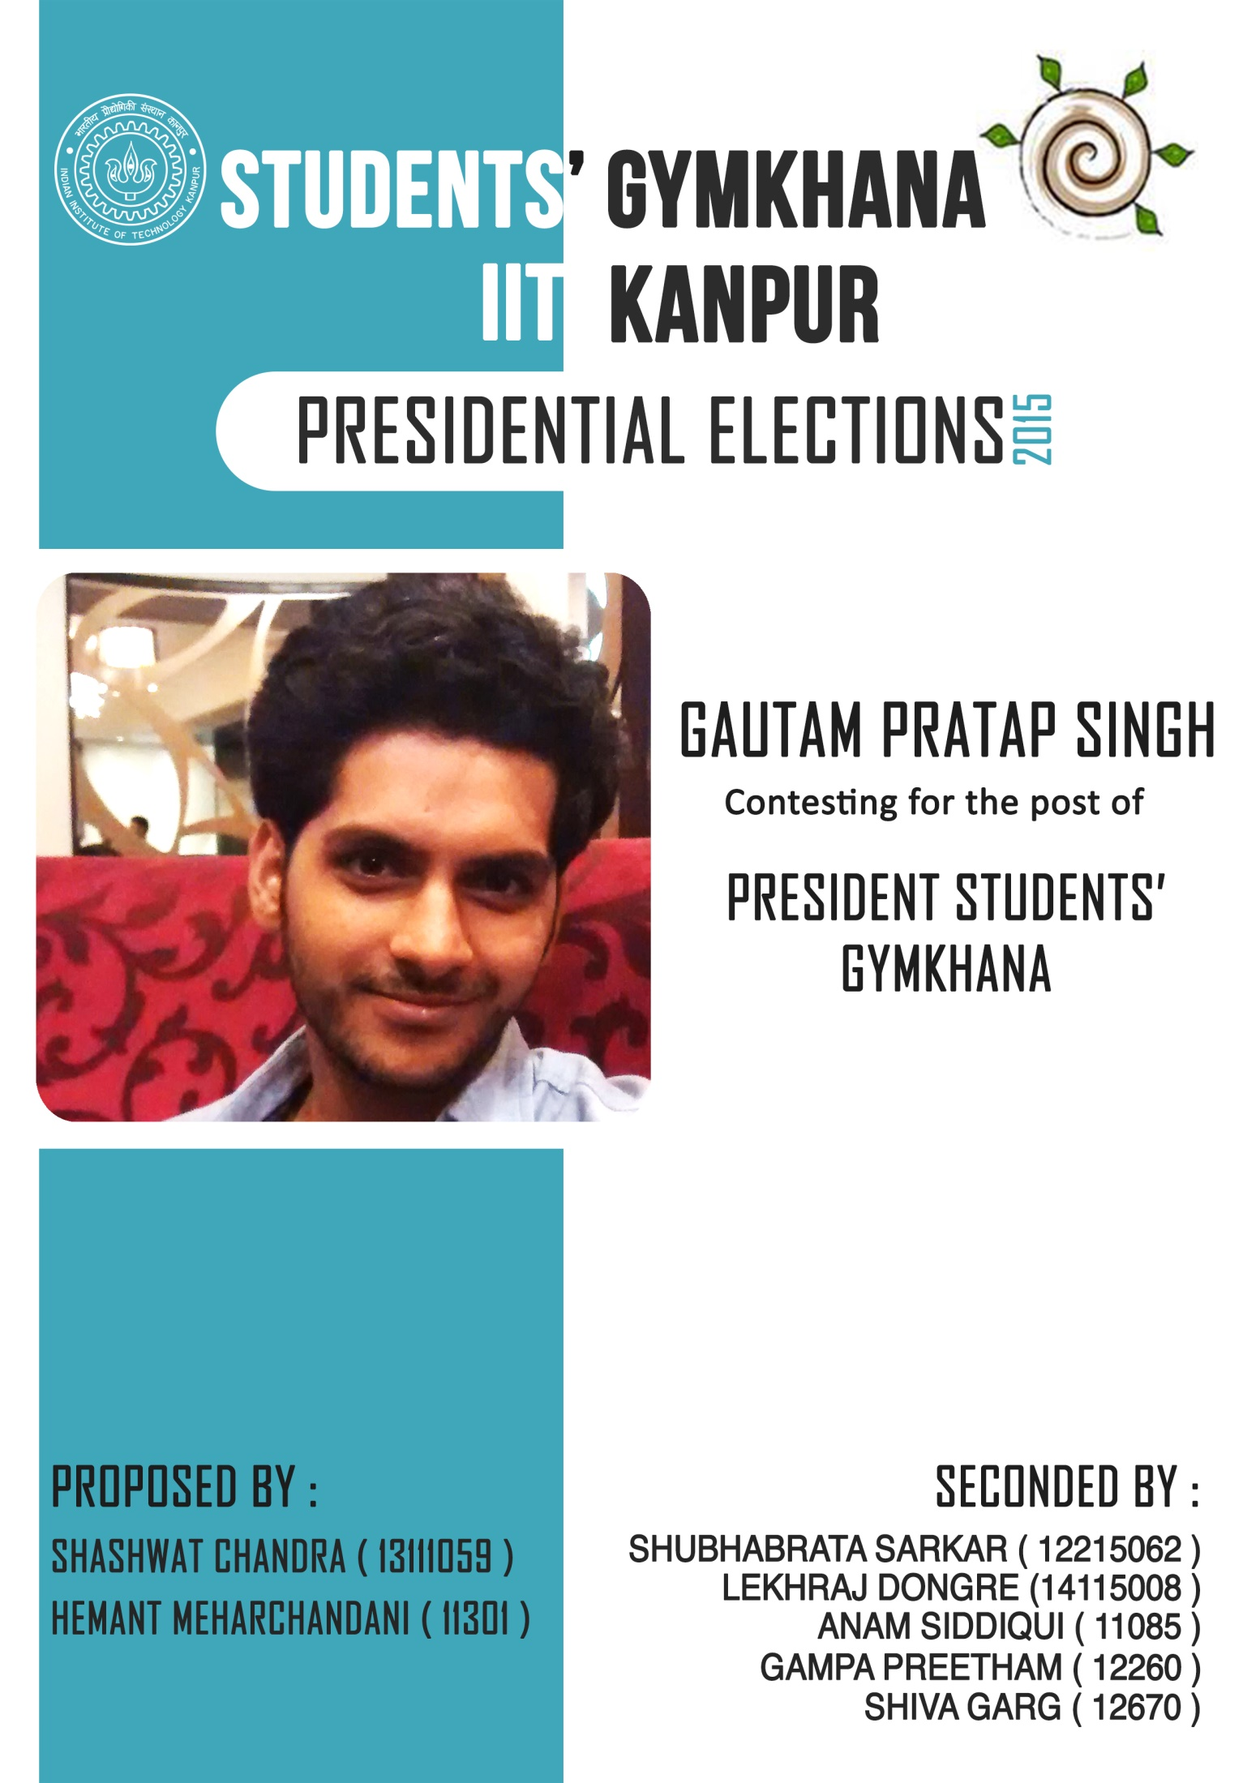

Vision
In the last five decades the Students’ Gymkhana has been functioning with the aim of redressing the challenges faced by the students via the genesis of proactive structures. Starting now I believe the student gymkhana should adopt the motto of

“IMPETUS”

The Institute and the Gymkhana have deliberated solutions to most of our problems. The only thing we lack now is the plan of implementation and a strong resolve to follow it. As a Chief Executive of the Students’ Gymkhana I wish that not only me but also every student of the campus should fight this dilemma, work upon new opportunities and try to take a step ahead on the path of progress.
Once we start working as a cohesive unit where every individual is playing his or her part in the betterment of the Student Life in this campus, we shall reach the status of a flourishing ecosystem where the faculty, staff and students come together to live a life enriching for all.

Mission
The Students’ Gymkhana plays the role of an administrative body, an advocate of our rights and a helping hand all at the same time.Over time the Gymkhana has functioned progressively to develop sufficient systems for the prevalent issues in the campus. I believe it has now become imperative for the Gymkhana to realign itself. I feel the need of the hour is no longer the creation of solutions but instead to enhance its efficacy. It’s time that we show heightened focus on bridging the gap between our aspirations and the manifestations of our collective efforts towards achieving them.
The focus of my tenure as the President, Students’ Gymkhana will be to not only propose new ideas but also to work upon the existing ones in an efficient and progressive manner. If I am able to follow up the work started by my predecessors and bring them to life, I am confident that we can create and pass on a momentum that generations to come will cherish.
Academics
The highest priority of every individual in this campus is to avail the unique academic experience offered by the institute. As the President of the Students’ Gymkhana, it would be my prime responsibility that these aspirations are fulfilled. Given the present challenges faced by the students, I wish to pursue the following-

Retrospective Minor
- Due to administrative limitations, minors are being offered to only a limited number of students, discouraging a vast majority of students from pursuing the same as presentlyeven if a student is able to complete the requirements of a particular minor, the minor is not awarded.

- I propose that the minor may also be offered retrospectively, hence allowing more students to get a minor.

Preponing timing to opt for double majors and minors
- As most departmental courses have perquisites, students opting for double majors and minors face problem in planning semester course template.

- To ease this, I propose that the students should be given an option to opt for double majors and minors in the third semester so that they have sufficient time to complete prerequisite courses.

Introduction of diploma
- Some students who are not able to cope up with the academics of the institute aren’t able to complete their degree requirements in the stipulated time.

- To acknowledge the coursework that they have completed in the institute, I recommend that a diploma be introduced which may be awarded in these cases.

Open Undergraduate Projects
- Most departments offer four undergraduate projects which are allowed to be taken only under the guidance of faculty of the respective departments.

- For the students who wish to take a project in some other department, I propose that the UGPs which are not compulsory for the degree requirements of the department be made open UGPs with no department limitations.

Research and Development
As a leading technological institute of the country IIT Kanpur is responsible to bring about cutting-edge research to make India a global leader in Science & Technology. As the President of the Students’ Gymkhana, it would be my prime responsibility to develop research temperament amongst the students. I’d pursue this by taking the following initiatives:

Collaborative Project
- Research requires collaboration of varied skill sets for creation of new knowledge base. The experience and research maturity of postgraduate students and the enthusiasm & curiosity of the undergraduates can be blended to give rise to state-of-the-art research.

- On these lines a project system was successfully introduced in the Civil Engineering department which included five UGs and five PhDs.

- I would make efforts to ensure that such collaborative projects be introduced in other departments as well.

Revival of PoWER
- PoWER, which arose as an avenue for students to get invaluable experience by involving themself in industrial projects was a powerful platform for promotion of R&D in the institute. The body has become inactive which has led to a loss of an intermediary between the students and the industry. I would proactively work in the revival of PoWER and its effective functioning.

STARC
(Student Technical and Academic Research Convention)
- A very crucial step in research promotion is the provision of opportunities to showcase the ongoing or completed research projects. This year a step was taken in this regard by organizing a research convention, in which many students participated & presented their work, which was reviewed by the professors of the institute. To further this effort and make this a bigger success, I’ll push for the organization of a large scale convention to instill a spirit of research in the student community.

CO-PAS
(Common Online Project Application System)
- There is a vast majority of students who are interested in pursuing research projects in the campus during summers but are unable to so due to lack of information and hesitation in contacting professors directly.
- To facilitate the project application system, I propose a common online portal where professors can offer projects available for the summers. Students would then be able to apply for projects through this common platform easing student-professor interaction and allowing the students to make an informed decision regarding the project they want to pursue.

Career
The selection of a career or profession is one of the most important things of life. But it is equally difficult. The lack of guiding services and proper counselling further complicates this matter. A right choice of a career is of fundamental importance. The more you know about yourself and career opportunities, the better able you will be to choose a satisfying career.

Career Guidance
- The Centre for Development of Soft Skills (CDSS) is an important step in career guidance in the campus. The development of CDSS is underway and as the President, I would actively involve myself in its successful establishment and implementation. The development of soft skills is a crucial element in enriching personality and is needed for the overall career development of all individuals. The present structure of CDSS focuses only onthesoft skill development of internship and placement applicants. I feel that the scope of CDSS needs to be widened so as to incorporate students interested in improving these skills for other purposes including those applying for research positions.

- Although CDSS is critical in career guidance, there still remains a vacuum as far as career counselling is concerned. I propose the introduction of Career Counselling Cell (CCC), a supplementary institute body which provides career counselling for all students in the campus through professionals, to help the students make informed career choices.

PhD placements
- Presently the Student Placement Office focuses mostly on placements of Bachelor’s and Master’s students. Hence most companies coming for the placement session don't cater to the profile of PhD students. I will collaborate with the SPO to invite more companies suited for the PhD students and provide guidance to them regarding the same.

Entrepreneurship
An important career decision is to choose between working for established firms and starting one’s own firm. The knowledge of entrepreneurship is necessary to make an enlightened decision on this.

Introduction of Minor in Entrepreneurship
- Most world renowned institutes today have realized the importance of entrepreneurship as an excellent career option and have started providing many courses and degrees to train the students for this. At IIT Kanpur, the need of similar changes has been realized by both the students and the faculty but no major step has been taken to this effect. I propose a minor in entrepreneurship which will provide students with a solid academic background and hands-on practical experience.

E Summit
- E Summit has been envisioned as a flagship event of IIT Kanpur which celebrates the spirit of entrepreneurship and makes IIT Kanpur a hub for nurturing India's future technopreneurs. This requires the E Summit to become more global in nature, bringing in students’ participation from across the country. With the gymkhana soon giving recognition to campus startups, E Summit should also work as a platform for interaction of campus startups with industry professionals and for the campus startups to interact with the world. I would coordinate with the E Cell to make efforts in this effect and make E Summit a nation-wide platform for start-up promotion and interaction.

Campus Life
Campus life is a time of varied prospects, an opportunity to live the dreams of a beautiful future; a time to have faith in the fulfillment of all desires and, a hope to explore all possible paths. My responsibility as the torch-bearer of the student’s representative body would be to ensure that a resident’s stay in the campus be an enjoyable and enriching experience.

Cashless Campus
- Cashless Campus is a popular concept among large universities and colleges, which enables students to pay for various campus services, without the hassle of carrying cash around to make payments. Presently, the IITK campus faces a lack of outlets which doesn’t allow cashless payment, causing inconvenience for many students.

- Therefore I propose to implement this strategy through a two-step process, the first of which would be the installation of POS machines enabling payments through one’s ATMs.

- Subsequently, student I-cards would be integrated in the process. This initiative will allow the campus junta to pay across most of the merchants just by the swipe of a card.

Health Center
- Despite the necessity of quality healthcare facilities, the campus Health Centre fails to reach to the levels expected by the campus residents. Apart from below par healthcare services, one of the major causes for this is the lack of proper infrastructure. A proposal in the Students’ Senate mentioned opening of a dispensary in the vicinity of Halls 1, 2, 3 and 5. The proposal was not considered feasible stating various reasons. Yet, I would make sure this issue is reconsidered and thought upon in a more efficient and deliberate manner. Also, I believe that the radiology center should be modernized and a new pathology center be opened, facilitating diagnosis and allowing early treatment.

Food Outlets
- The development of a new student lounge, in the area below L-7, is underway and it is currently being refurnished. Initiatives would be taken by me to ensure the opening of food outlets in the same, which would ease students to refresh themselves between long hours of study in the proximity of LHC.

- Along with this, I plan on the installation of food vending machines across the Academic Area and in the New SAC region, so that residents have access to eatables and drinks round the clock.

Transport
- Due to a large campus size and a fairly high number of people commuting through it on a day-to-day basis, the campus junta faces a lack of appropriate transport facilities. To counter this problem, I plan on the introduction of cycle rental centers, where students would be able to rent cycles for a minimum duration. I would also initiate intra-campus bus services during peak hours.

Women Security
- Women Security Cell has limited student participation in it. Gymkhana will have three female and a male nominee in it. This will increase the accountability of Cell towards the problems. Also, increasing student representation will improve functioning as they have deeper roots in campus community.

- Helpline will be functional throughout the year and extreme confidentiality will be maintained. Regular feedback and suggestion will be taken from girl representatives.

- During festivals, we unfortunately lack a secure and women friendly environment due to footfalls of large number of outsiders. A Women Security Head will specifically be made to keep a check on women security.

Students’ Gymkhana Governance

Club and Hobby Groups
- Our clubs are increasingly becoming passive bodies and in some cases have lost their purpose entirely. The idea is that every club must propose a set of objectives they hope to achieve at the beginning of the gymkhana term. These objectives shall be presented before the Senate after the charge-handover through pre-term reports of all councils. Further, the progress made on the objectives will be reviewed in the mid-term and end-term reports of the councils.

- I also propose dynamic promotion and demotion of hobby groups and clubs respectively by gauging performance in the previous terms.

De-cluttering Gymkhana Calendar
- An innumerable no. of events right now results in a jam-packed weekend every time. I plan to de-clutter the calendar through a limit on the no. of events clubs and hobby groups can conduct in a term.

Accountability & Transparency
- I propose that all elected executives maintain an online page wherein they put up their manifesto and keep updating their timeline according to the actions they take. The page should have a comments section through which the concerned executive will be held accountable.

- I propose that the Journalist Society should give a mid-term and end-term review of the work done by all executives and the senate.

Hall Governance

Hall Allocation Policy
- Hall Allocation Policy (HAP), one of the most important issues for a student, is directly presented in COSHA for discussion where opinion of all the students cannot be put forward. An Open House session will provide a platform for everyone to express their problems and give suggestions.

Open House Sessions
- Students are on the receiving end of every Gymkhana activity and thus are the best critique. To improve functionality of Gymkhana open house sessions will be conducted after every mid-semester examination. This will not only be a platform to criticize, raise questions and suggest changes but will also increase accountability of Gymkhana towards students as in a true democratic setup.

Warden Selections
- Unlike Deans’ selections, students don’t play a role in the selection of Wardens for the Halls. The system needs to be changed such that the student HEC will have a word in selection procedure of hostel wardens to let authorities know about students’ will. Hostel warden of choice will not only improve students’ interaction with him/her but will also help him/her in functioning.

Infrastructure

New SAC Extension
- The proposal of New SAC has been passed. I will push to initiate it’s construction students and ensure its timely completion. I propose the following to structure according to the present need:
- Ground floor will comprise of an auditorium of capacity around 400 and a multipurpose hall to be used both as Vivekananda Youth Leadership Convention Centre (VYLCC) and for Gymkhana Activities.
- First floor will be customized as Science and Technology Floor. It will comprise of Robotics room, Electronics room, Lab for Institute Teams and an S&T vault.
- Second floor will have a center for each festival team and will partially be occupied by a flourished food court.

Hall 3 Food Vendors
- I will ensure organized and regulated vendors in front of Hall 3. Proper shed and facilities will be provided to them. Presently shops are unregulated and this will help in keeping a check on quality, rate and variety.

Canteens and Messes
- Most hostels face a crunch which leads to space congestion in messes and canteens. Extension of canteens will take place wherever required. Also, GH2 Mess will have enough space for residents of both GH2 and GHT.

New Residential Avenues
- Proposal for the construction of GH2 and Hall of Residence 12 has been passed but there is an urgent need for early construction of these to solve accommodation problem. I will not only stress for their early initiation but also propose Hall of Residence13 to completely resolve congestion.

Wi-Fi Enabled Residential Areas
- I believe that there is a need to provide Wi-Fi facility in all residential areas to improve internet accessibility, and hence would work on the same

Gymkhana Payment Automation
- The payment of gymkhana dues; sale of festival merchandise, book club dues etc. is presently being done manually, which is often quite inconvenient. Hence I would take initiative in bringing all gymkhana related payments online.

Online Event Planner
- Creation of an integrated online gymkhana calendar and event planner is necessary to ensure synergy within the body. As the President, I would make sure that this calendar is developed and is easily accessible to the students via a gymkhana app, electronic notice boards and time management applications.

General Championship Website
- There would be a website dedicated to the General Championships which will post all related updates. The inter-hall festival websites will be hosted under its domain. A separate Gymkhana Webmaster will be appointed to maintain this site and the Interactive Calendar.

Presidential Office and Council

President’s Core Team
- There are a number of President Nominees in various institute committees, who take decision on various student related issues. But there is a lack of a formal platform where the President gets briefed on the issues raised and the decision taken in these committees. Hence I envision a President’s Core Team, comprising of these nominees so that there is a proper channel of decision making.

NGO Chapters
- I propose the creation of a separate body called “NGO Chapters” in the Presidential Council which will act as a gateway for existing NGOs to establish themselves in IIT Kanpur. The Presidential Council would help the NGOs to connect with students interested in aiding or joining them. They would also be given the opportunity to carry out independent fund raising campaigns. This would help promote an atmosphere of community service in the campus, with even more NGOs getting connected to the campus.

Students’ Welfare Cell
- Students' Welfare Cell (SWC) has taken various initiatives to tackle persisting problem in the student community. In addition to its existing role, I feel that the SWC can also play a key role in helping specially challenged students by helping the institute identify major problems faced by this student community and proposing a solution for the same.
- The setting up of a portal for peer review of academic courses would help the students in selecting courses by providing them with the feedback and insights of students who have previously taken the courses. I would work together with the SWC to come up with a suitable portal to this effect.

International Relation Cell (IRC)
- The IRC was setup with the objective of coordinating with OIR toprovide international exposure to students at IITK by collaborating with world renowned institutes for semester exchange and projects. But I feel that the scope can be widened to include career fairs and cultural exchange so as toinvigorate the original vision embodying this unit.

Mélange-Presidential Council Weekend
- Presently, the various factions of the Presidential Council organize their individual events which are scattered throughout the Gymkhana Calendar. I aim to bring these events under a single event, Mélange, which would be organized on the weekend reserved for Green Opus activities.
- The primary focus of this event will be to increase relevance of other clubs in the Council by making them a part of the General Championship. Preexisting events, like those of the E-cell would be shifted to this weekend and newer events of Book Clubs would be introduced.
- As its secondary goal, this event would serve as a platform for the exposure of relatively underrated clubs by organizing events such as Udaan, Book Fair and a session by VivekanandSamiti.

Credentials and Achievements

- Acting President, Student Gymkhana (May'14-July'14; Dec’14)
- Head, Presidential Council (March’14-Present)
- President, Hall of Residence V (July’13-July’14)
- Overall Coordinator, Bon Voyage’14 and Yearbook’14
- Chairman, Student’s Gymkhana Automation Committee, Student’s Senate’14-‘15
- President's Nominee, Institute Advisory Committee Meetings
- President’s Nominee, Academic Senate Meetings
- President's Nominee, CEMMC Meetings
- President's Nominee, Institute Automation Committee Meetings
- President's Nominee, Convocation Awards Committee
- President's Nominee, Convocation Refreshments Committee
- Member, Institute Anti-Ragging Committee and Institute Anti-Ragging Squad
- Volunteer, Students’ Placement Office’12-’13

Academic Bodies
- Student Nominee, DUGC, Mechanical Engineering ’14-’15
- Academic Mentor, Counselling Service’13-’14

Clubs
- Secretary, Business Club (April’13- March’14)
- Secretary, Films Club (April’13- March’14)
- Active Member, Dramatics Club

Festivals
- Principal Security Officer, Antaragni’14
- Workshop Coordinator, Techkriti’14

Work Done
- Assisted the President, Students’ Gymkhana in Hall Allocation Policy’14-‘15
- Assisted the DOAA in successful organization of Convocation’14
- Led a pool of 1400 students to secure 1st runner-up position in General Championship’13-’14, winning Takneek’13, Spectrum’14 and Fresher’s Inferno’13
- Led a team of 25 people to secure 1st runner-up position in Dramatics Event, Galaxy’14, winning Street Play and Skit
- Scripted and acted in Skit and Street Play in Galaxy’13, the team going on to win the Dramatics Trophy
- Performed 3 Stage Plays and 1 Street Play as a part of Dramatics Club’13-‘14 and participated in Antaragni’13
- Scripted, directed and acted in 11 short videos for Spectrum’13, Spectrum’14, Green Opus’13 and Green Opus’14
- Scripted, directed and acted in 5 radio productions for Spectrum’13 and Spectrum’14
- Designed products in Jugaad, Takneek’14; Jugaad, Takneek’13; Mechanical Design, Takneek’12 and Mechanical Walker, Takneek’12

Your valuable suggestions are invited.

Thank You!

Gautam Pratap Singh

