CULTURAL COUNCIL
END TERM REPORT
(2014-15)

Submitted by
Shaleen Mandowara, General Secretary,
Cultural Council

Introduction
The council mainly functions through six clubs to conduct various activities. The structure of the Council Council is given below with the names of club coordinators.

Dance Club
Dance extravaganza
- Conducted on 12th January 2015.
- This is the annual showcase of dance club where it performs variety of dance styles including hip hop, salsa, contemporary, folk, indian etc.
- This event attracted huge participation and all of students were successful in putting up a great show for the audience.
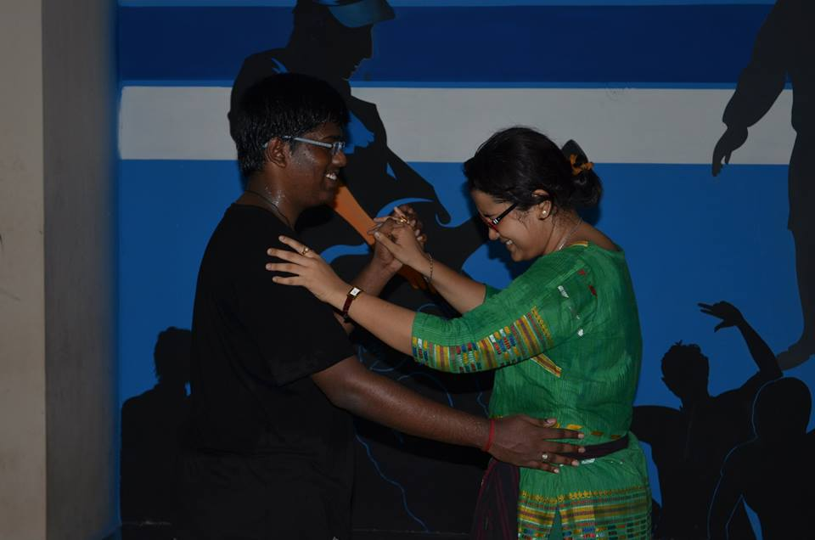
Workshop for all
Professionals: By Caroline D’Souza and Jishan Ali, Kanpur
- This is an open workshop for all the residents of the campus.
- Various dance styles such as salsa, jazz, Bollywood, freestyle, contemporary etc. are being taught.
- Dates: 10th to 19th march 2015

Dance-Pe-Chance
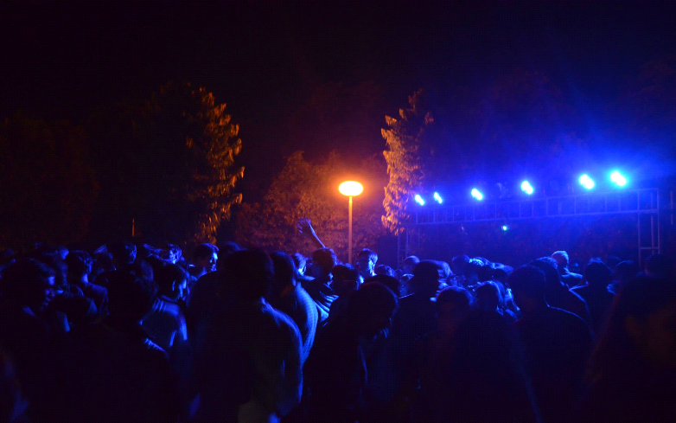
- This is a competition for non-dance club residents of iitk.
- Includes various contests like solo, duo, group and imoromptu.
- Happening as part of CULT-X
- Prizes and goodies to be won.
- Dates: 28th march 2015

Dramatics Club
Initiatives
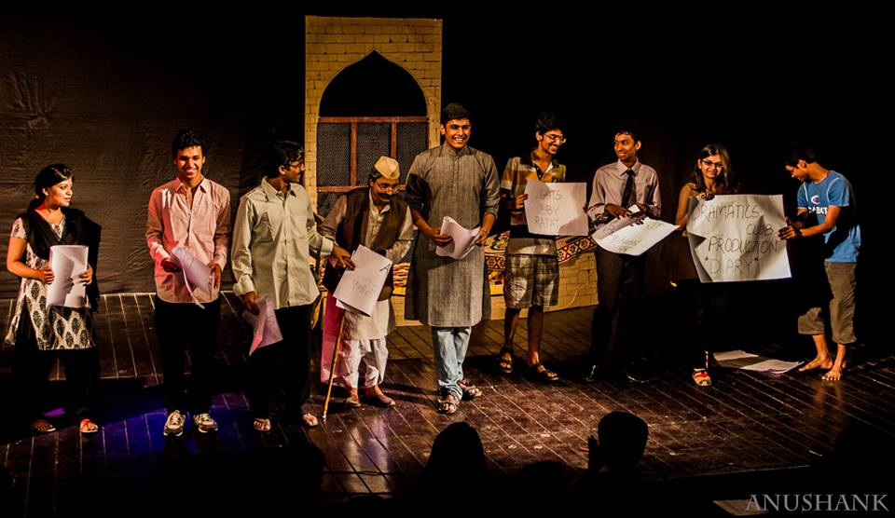

- Self-written play in summer workshop DAIRY.

- NUKKAD WORKSHOP - by Shilpi Marhawa
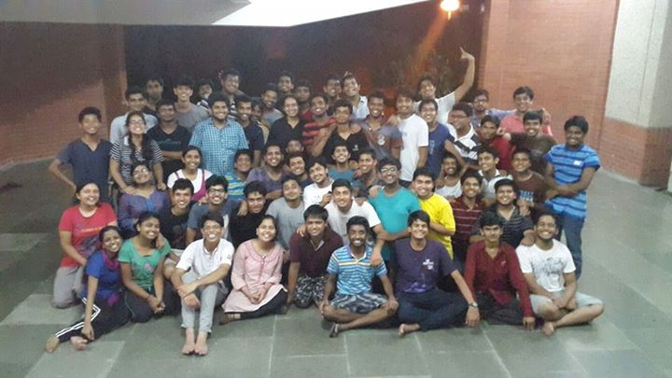

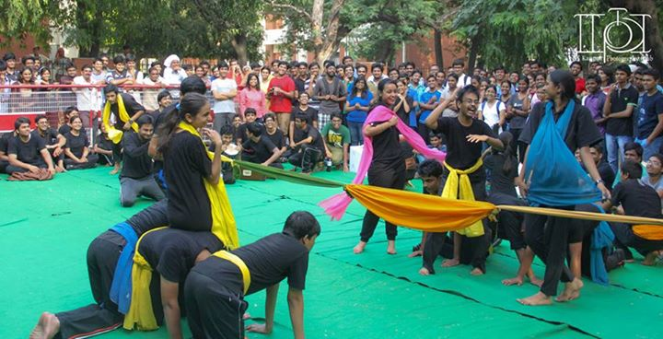
3) PG PARTICIPATION IN DRAM EVE AND ANTARAGNI

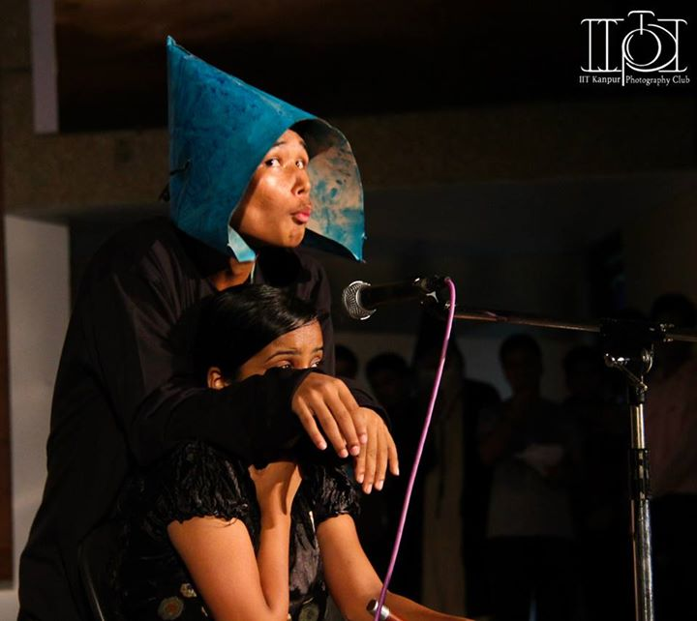
- Self-written Fresher skit

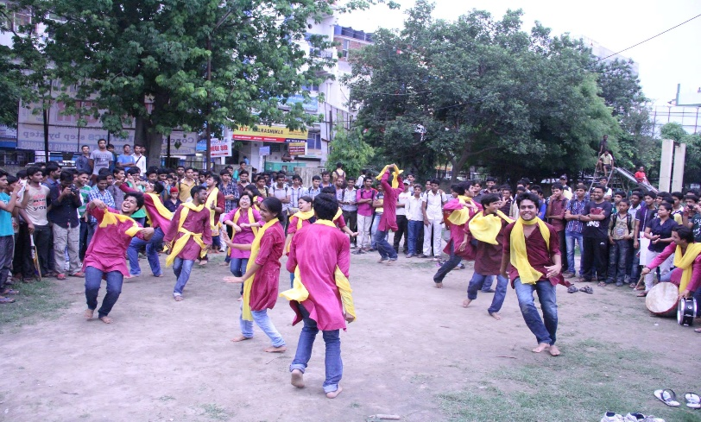

5) Performed Nukkad in Kanpur City, Kakadeo.

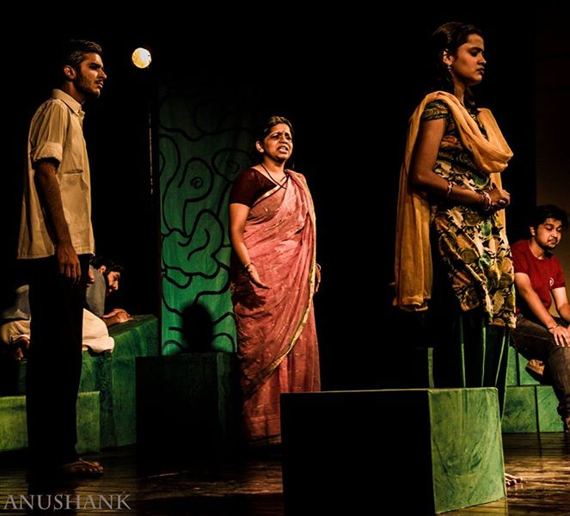
6) Performed Play “Vasansi Jeernani” in Merchant Chamber, Kanpur City.

7) Proposed Events:
In CULT-X, we plan on performing two Street Plays, one English Play and one Hindi Play.

English Literary Society
Initiatives/Activities
Run up to Galaxy:
Dumb Charades, JAM and Word Games were conducted before Galaxy. All of these events saw considerable participation from various halls. There were quite a few beginners as well. A few workshops were also conducted in various halls during this time.
Galaxy:
JAM, Word Games - Written Round, Creative Writing, Dumb Charades, Mixed Bag and Word Games - AV Round were the competitions conducted during Galaxy. Creative writing was adjudicated by Prof. Suchitra Mathur (IITK). The events which had open participation, like Word Games - Written Round and Dumb Charades saw massive turnouts.
LitFest:
As part of CULT-X ,Sonnets of Spring (https://elsiitk.wordpress.com/2015/03/12/sonnets-of-spring/), an online creative writing competition adjudicated by Samit Basu, the author of the critically acclaimed GameWorld Trilogy, is being conducted. Along with this, we will be conducting a Lit-quiz and a Poetry Slam
Miscellaneous
- Among the significant miscellaneous activities of ELS, one of the most important one was starting of the ELS blog (http://elsiitk.wordpress.com/). The blog is updated regularly with quality content and has a very healthy traffic.
- ELS also conducted a session of discussion with Ms. Shweta Taneja, the author of a few acclaimed books (http://staneja.com/), who was in the campus for a couple of weeks.
- ELS also conducted essay and poetry competitions as a part of the National Education Day celebrations on 11th November.

- ELS conducted an online haiku writing competition which was judged by Ms. Shweta Taneja in December and January. (https://elsiitk.wordpress.com/2014/11/10/haikuing-in-winters/)
- In the first week of January, ELS published a literary newsletter - Meander. Description of the publication and a copy can be found on the blog. (https://elsiitk.wordpress.com/2015/01/01/meander-a-literary-publication-by-els/)
- ELS also conducted a Poetry Meet in March which was a precursor to the Poetry Slam conducted during LitFest.

Hindi Sahitya Sabha

Initiatives and Activities:
- Hindi Learning Classes:
In summers' 14 and during the 1st semester, Hindi Learning Classes were organized for non-Hindi speaking community of the campus. These classes were taken by secretaries of the club- Arindam Raj, Abhay Kumar Singh, Garima Siradhana.
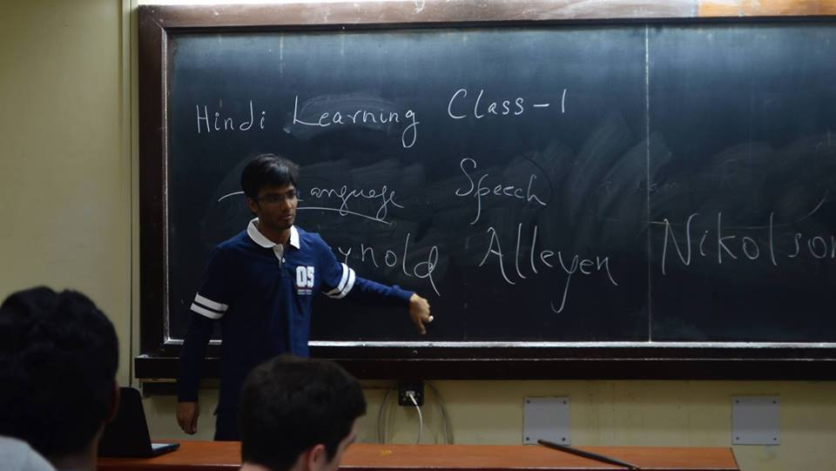

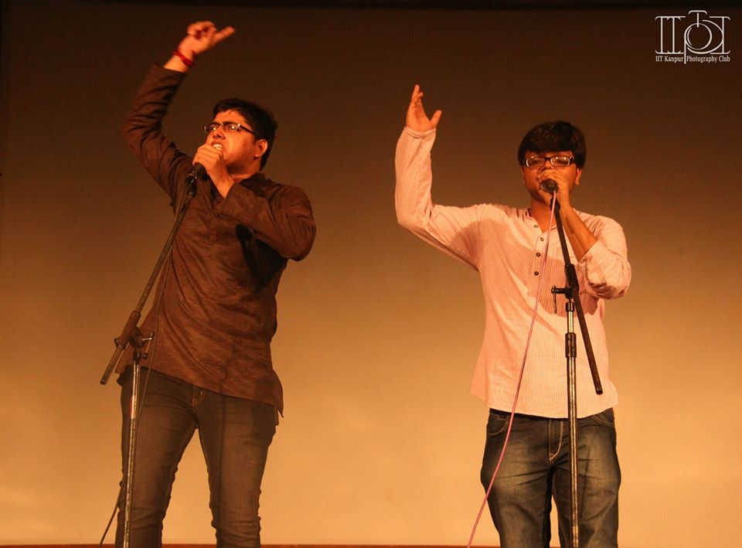
- Freshers’ Night
After not giving any performances last year on Freshers’ night, Hindi Sahitya Sabha was back with a bang to perform a skit for the freshers and by the freshers on the Freshers’ Night. The skit was highly appreciated by the freshers’ who went roaring during the performance. This was only possible due to tremendous efforts put in by the secretaries of the club.

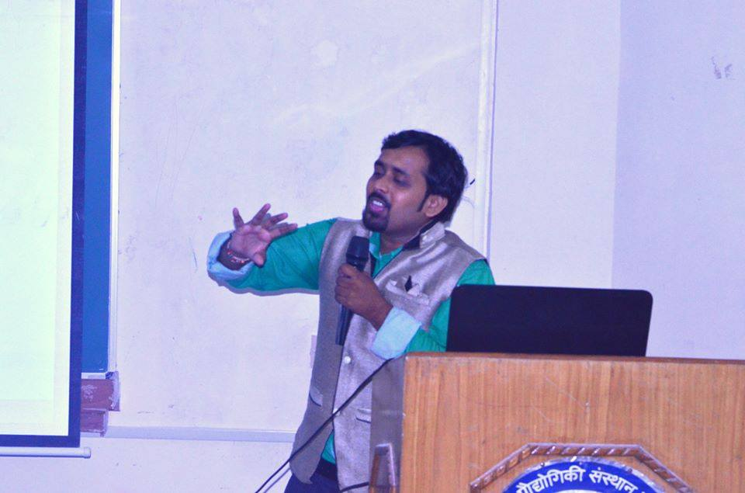
- Poetry Meet
A regular meet is being called for the progressive writers and the poetic enthusiasts of the campus to discuss works of legendary writers. In the coming semester, this meet would be opened to all.

- Workshop on Creative Writing
Dr. Pankaj Prashun, Yuva Ratna awardee at Lucknow Mahotsav, was invited for the lecture on "Confluence of Poetry and Science". The focus of the lecture was on the various forms of literature.

- Hindi Pakhwada
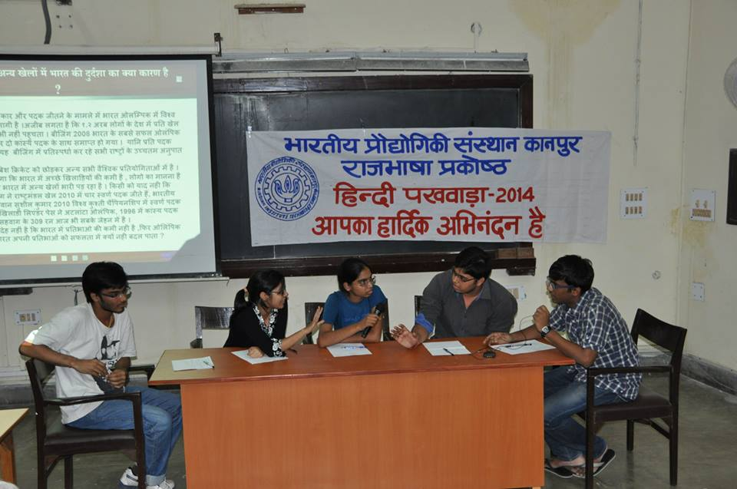
Literary competitions were conducted with the help of Institute Hindi Cell in the month of September to mark the occasion of Hindi Divas. These competitions included Panel Discussions, Kavyanjali, Debates etc. other competitions. The main aim of the event is to promote the activities among the non-active members of the club and faculties.

- Treasure Hunt
The treasure hunt was organized in association with English Literary Society and Quiz club. This night long event witnessed a participation of more than 400 students making it one of the most popular event conducted for the Freshers’ this year.
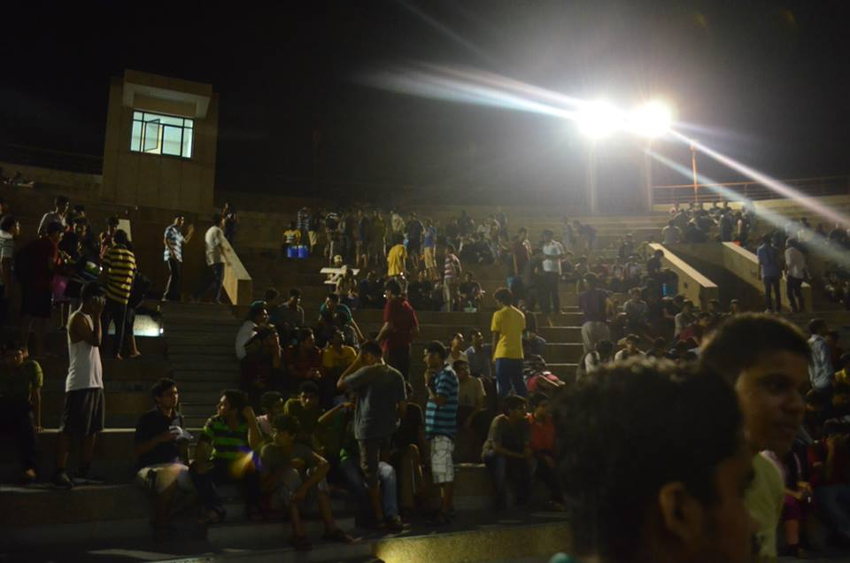

- Creative Writing Competition for Freshers
A creative writing competition was held for 1st year students in order to bring out the talent of writing in them. Most of the entries received were excellent, showing the presence of literary genius in the freshmen of our institute.

- Hall Level Group Discussions
For the development of good communication skills, Hindi Sahitya Sabha took an initiative of conducting Hall level Group discussions which were open for all.
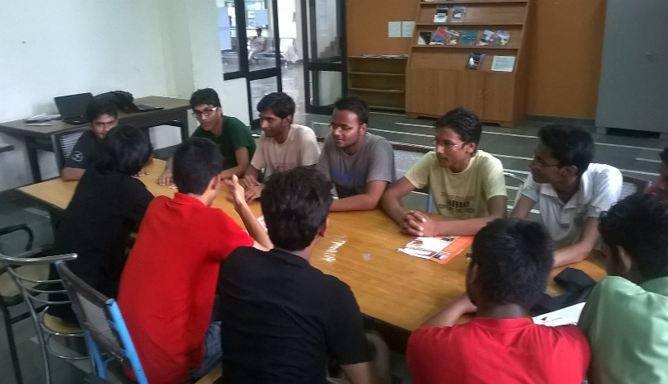

- Shaam-e-Masti
A fun-filled evening for the first year students was conducted which saw participation of students in activities like Dumb Charades, Word Games, JAM etc. This served as a great way to relax for the students in the tensed environment of quizzes and preparation for end sems.
- Galaxy
In Galaxy, the inter hall cultural competition, there was substantial first year participation from most pools which will help us in extending the reach of our club. A new competition on Review writing was introduced this year along with revival of JAM which was not conducted last year. All the four pools performed very well, but Mauryans won the trophy finishing ahead of everyone.
Story telling competition “Kirdaar” was reduced to merely a story writing competition in order to reduce the burden on pools.

- Hindi Learning Classes:
In 2nd Semester Hindi Learning Classes were organized for non-Hindi speaking community of the campus on two levels- Basic and Advanced. These classes were taken by secretaries of the club- Arindam Raj, Garima Siradhana.

- Nirvaak
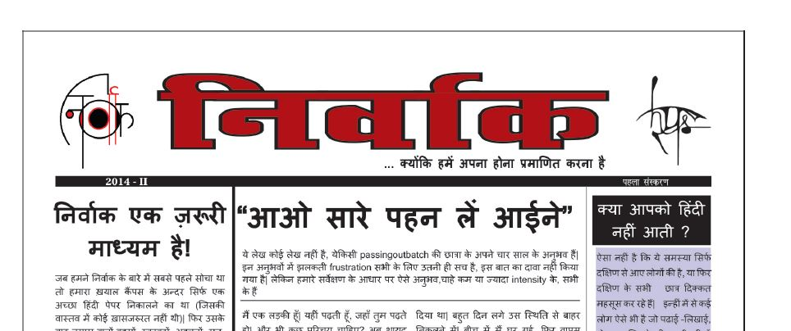
The first edition of Nirvaak, a views letter focusing on campus issues, was published. The main vision of Nirvaak is to give voice to those issues of our campus which have been highly ignored. We not only aim to bring out the issues but also to make sure that a well thought solution to the problem is implemented. The response to this from campus community was mixed, and our team is working to improve it on many fronts. An open meet to discuss the issues and the first edition of Nirvaak was also conducted. Nirvaak is also being moved to a blog in order to have an immediate say on issues.

- Poetry Meet
A regular open poetry meet for all was being held in January which focused on progressive writers of Hindi for the poetic enthusiasts of the campus to discuss their works of the poets.

Proposed Events
In CULT-X , we plan on conducting a session on Journalism and a session on Literature by distinguished guest speakers. This will be a motivation for people interested in Literature and Journalism.

Fine Arts Club
Please go the following link :-

https://docs.google.com/document/d/1dg7Fn9AhlgJEpOgNw9zzNx3sxLUk-9o6dHZ0gm5Dqgw/edit

Quiz Club

- The Galaxy quizzes were prepared by the QC Alumni Association. The quizzes were hosted by Apratim Tiwari, a student of the 2009 batch, who accepted our invitation.
- A new quiz in the Mahaquizzer format.
- A popular choice “Junta Quiz” was held. Its topic was Cricket world cup quiz. It witnessed participation of over 20 teams.
- Standard quizzes like GenQuiz, MELA and India were held.
- Special quizzes like HELM also took place.

Upcoming Events:
Unconventional Quizzes in the upcoming CULT-X include quizzes like anti-mela, lit quiz, etc.Sports Quiz with Inferno’15.

Debating and Discussion Society

The society has aimed to foster an environment for healthy debates and discussion. The following events were conducted through the year:
- Oration Mania: Consisting of an MUN Workshop, a Fresher’s debate championship and a group discussion, Oration Mania was conducted in the month of August.
- Antaragni: IIT Kanpur placed in top three in the best adjudicator competition
- Galaxy: Competitions in Galaxy comprised of a Security Council, a Parliamentary Debate and a Presidential Debate.
- CULT-X: Future plan of the Society is to simulate a General Assembly in Cultural Extravaganza.

