Students’ Gymkhana General Elections 2016

AYUSH SHAKYA

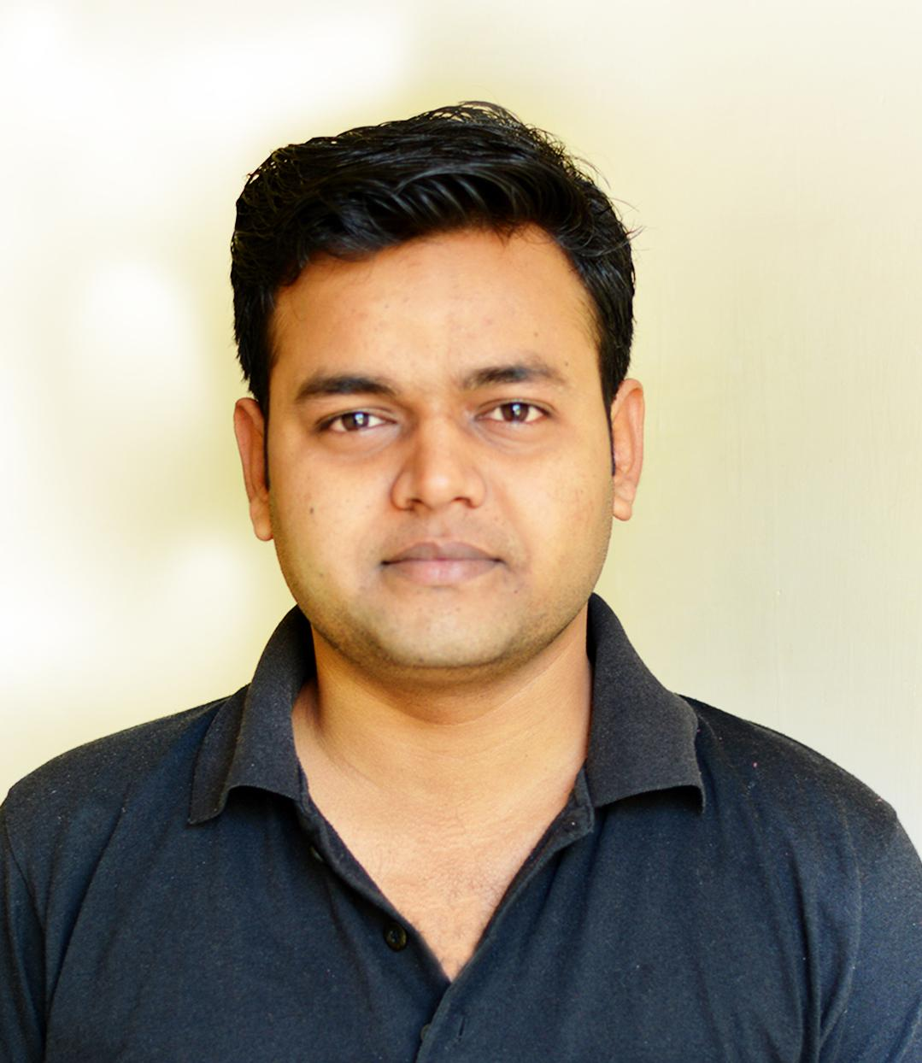

Candidate for the post of
GENERAL SECRETARY
SCIENCE AND TECHNOLOGY COUNCIL

Proposed by: Seconded by:
1. Harshit Rathore (12290) 1. Aditya Pande (13046)
2. Ashish Singh (10107064) 2. Rachit Agarwal (13524)
3. Shubham Kumar (13685)
4. Sanjari Srivastava (13618)
5. Lekhraj Dongre (14115008)

VISION

My vision for the campus will bring student activity in consonance with the broader technological forum. The aim is to promote students from the grass root level bootstrapping them through Takneek, gradually improving skills, developing capabilities to plan and implement more involved, through cutting edge projects. To that end, barriers between clubs will wither facilitating the utilization of the diverse skill sets that different clubs develop. Corporate ties will be fostered for support so that students can learn how to contribute at the ground level of a growing company. The outreach of the council will be expanded keeping in mind the interests of both the under graduates and the post graduates. This will form a sustainable, organic integration of various clubs into the technological community of IIT Kanpur and help us develop a holistic culture to compete better in other external contests.

MISSION

- Increase collaboration between the clubs and hobby groups through inter disciplinary projects.
- Increase participation in renowned competitions.
- Tie-ups with alumni, corporate sector and faculty for better opportunities.
- Target PGs for mentorship so that they can work along with UGs.
- Social initiatives to be undertaken by the council to give back the society.

Improving Takneek:

Quality over quantity
- Currently Takneek has too many events to schedule them properly in such a short time, which leads to overload of events, so I will propose to keep the number of events less than previous Takneeks.
- There will be at-least one event for fresher from each club or hobby group.
- Events that involve back stage judging will be brought to the front stage by setting up a judging panel, announced before the event.
- Events like Crypto, Science Quiz, Giant Particle Chess etc. which don’t require much preparation will be conducted in the same weekend as that of SNT Code.

Recognition
- Currently, Takneek awards prizes or trophies categorized on basis of clubs or hobby group and does not focus much on recognizing individual efforts.
- Individuals will be recognized through certificates to every winner which will incentivize people specially freshmen. Number of team members will be finalized at the time of event registration by each club and hobby group, and the distribution will be done on the last day of Takneek.

Inter IIT Tech Meet:
- Propose more events that require applied engineering, events that involve optimization of performance to achieve a certain aim.
- A proposal to MHRD through DOSA and Director to get approval for Inter IIT Tech Meet, for better resources, recognition and participation.
- Spread awareness about the competitions through Newsletter and Social media.
- Provide better recognition to the winners of the competitions by Student’s Gymkhana.

Project organization and collaboration:

Project plan and outreach
- Launch long term projects on a council level to promote inter-disciplinary activities.
- This will encourage collaboration between clubs.
- Make all inventory in clubs public to the campus community through their websites and SNT page for further outreach.

Organizational structure
- First wave of recruitment for long term projects before summers, so that work can commence in the Summer Camp.
- Second wave of recruitment will be conducted after Takneek to fill in gaps and new projects will be introduced.
- I will propose a Winter Camp to be organized by SNT Council to continue work on these projects.

Caution Money
- While receiving caution money from the students, all clubs or hobby groups will provide them a receipt mentioning the terms and conditions.
- Through the receipt they will be informed about the expected date of return of their amount and if any part of it is consumed in any way by the council, the students will be informed beforehand.

Corporate and Academic Collaboration
- Include projects in trending topics in all the fields in which our clubs work.
- Identification of potential areas which are feasible and haven’t been explored till now example- data mining, swarm robotics and adaptive control etc.
- Include departmental facilities in such projects. Try to involve faculty, as projects in the fields of interests of professors will surely attract them towards the council.
- Collaborating with faculties can result in awarding UGP credits to students working in long term projects.
- Include corporate tie-ups and industrial projects in the council plan, this will provide us with more opportunities and resources along with an industrial experience for the students.
- Get journalists to cover SnT Pavilion, SnT day and the remaining yearlong activities of the council which will boost the popularity of the council in and outside the campus.

Finance and Management:

Financial Executive System
- A restructuring of the responsibilities of the financial executives to make the entire process more efficient. Club coordinators will only have to get the bills verified and contact the respective financial executive assigned to that club or hobby group.
- Financial Executives will take care of entire bill management right after the verification.
- Status of bills will be maintained online in a portal to increase transparency.

Online Lecture Hall Booking
- Already this facility is available for the faculty but not for the students, we will try to get it implemented on the council level under the new office automation system PINGALA.
- If any club or hobby group needs to conduct a lecture the coordinator or the hobby group leader will just have to inform the General Secretary and the request will be sent to faculty advisor of the council after whose confirmation mail and approval by the DOSA, the lecture hall will be booked.

Tools and Components Store
- A centralized store where all the tools and components used by pools, coming from Gymkhana budget during Takneek will be stored.
- An online inventory will be maintained, these components can be issued and used by general body members whenever they need.
- In case a component is not returned the equivalent amount which will be mentioned at the time of issue, will be added in the Gymkhana dues of the person.

Tinkering Lab
- Install new machines and make them functional.
- Conduct workshops for operating various machines such as 3D printer, water jet etc. that are already available in the lab.
- Spreading awareness among students about the Tinkering lab and its facilities.

Public Relations:

Online Presence
- Use social media extensively to reach out to new students and showcase the activities of the council.
- Recognize the efforts of the winning teams from different events by wishing them on social media.
- Develop a dedicated Discussion Forum for the council projects and activities to promote healthy discussion and diverse ideas.
- Invite professors and alumni to be a part of the online Discussion Forum.
- Council website will be restructured to publish the council activities, upcoming events, relevant contact details and the exact procedure regarding finances and lecture hall booking.

Newsletter
- A quarterly magazine containing details about ongoing projects of the council, past achievements and future plans.
- Will be sent to faculty and students of the campus to reach out to them and spread awareness among them.

Alumni Contact
- Take slots in Alumni Meets for SnT council and present our council activities before them and try to get support for projects from alumni in whatever way they feel free.
- Separate team for contacting alumni under the Marketing Cell of the council, so that we can take a step in building new relations.
- Organize talks by successful alumni in their respective fields on SNT Day and other events to encourage our tech enthusiasts and entrepreneurs.

Outreach to PGs
- A new position of mentors will be introduces under SnT council targeted at PGs so that they can provide guidance on higher level projects and be a part of the core team.
- Publicity of lectures, workshops and other events not limited only to UG halls.

Social Initiatives:
- Try to improve surrounding villages like Nankari etc. by including projects in the council targeted towards solving the problems faced by them in collaboration with RuTAG.
- In collaboration with Prayas will conduct workshops on a very basic level, to give those children a hands-on experience.

Core Team Structure:

Credentials:

Achievements and Initiatives
- Secured 1st position in Pitch Your Product, E-Summit 2014.
- Secured 2nd position in ECDC, Techkriti 2015.
- Secured 3rd position in Electromania, Takneek 2013.
- Secured 11th position among 89 teams on national level in ABU Robocon 2015.

- Started a new event in “Electrowiz” in Takneek to promote “Maker Spirit” among fresher.
- Organized a Hardware Hackathon within the students participating in Winter School, Electronics Club.
- Conducted a workshop on “Ideation and Design” by Prof. Raman Saxena in collaboration with E-Cell.

Projects and Technical Experience
- Sensor Controller Network for Smart Grid (May 2015 - July 2015)
under Dr. Lakshmidhar Behera

- Clean Energy Recharging the World, ABU Robocon 2016 (October 2015 – Present)
under Dr. Bhaskar Dasgupta

- Robominton, ABU Robocon 2015 (October 2014 - March 2015)
under Dr. Bhaskar Dasgupta

- 3D Laser Scanner, Summer Project 2014 (May 2014 - June 2014)
under Electronics Club

Positions of Responsibility
- Coordinator, Team Robocon 2016
- Coordinator, Electronics Club (2015-16)
- Senior Member, Team Robocon 2015
- Science and Technology Secretary, Hall Executive Committee, Hall-10 (2014-15)
- Secretary, Electronics Club (2014-15)

